Data Set – Train and Test Folders

|  |  |
| --- | --- |
| **TEAM ID** | **PNT2022TMID54147** |
| **PROJECT NAME** | **Real-Time Communication System Powered by AI for Specially-**  **Abled** |
| **DATE** | **11-11-2022** |

D:\

|  |
| --- |
| D:\IBM Project |
|  |
|  |

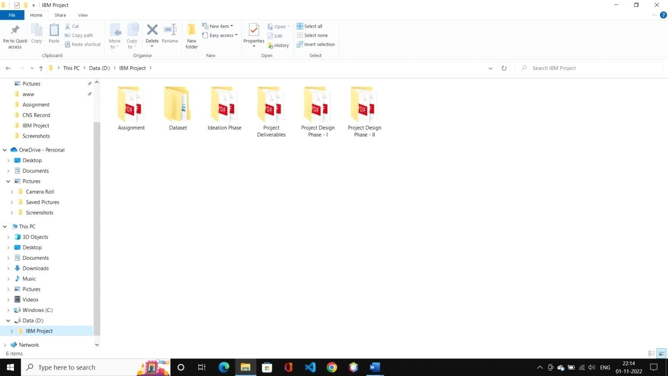

\Dataset

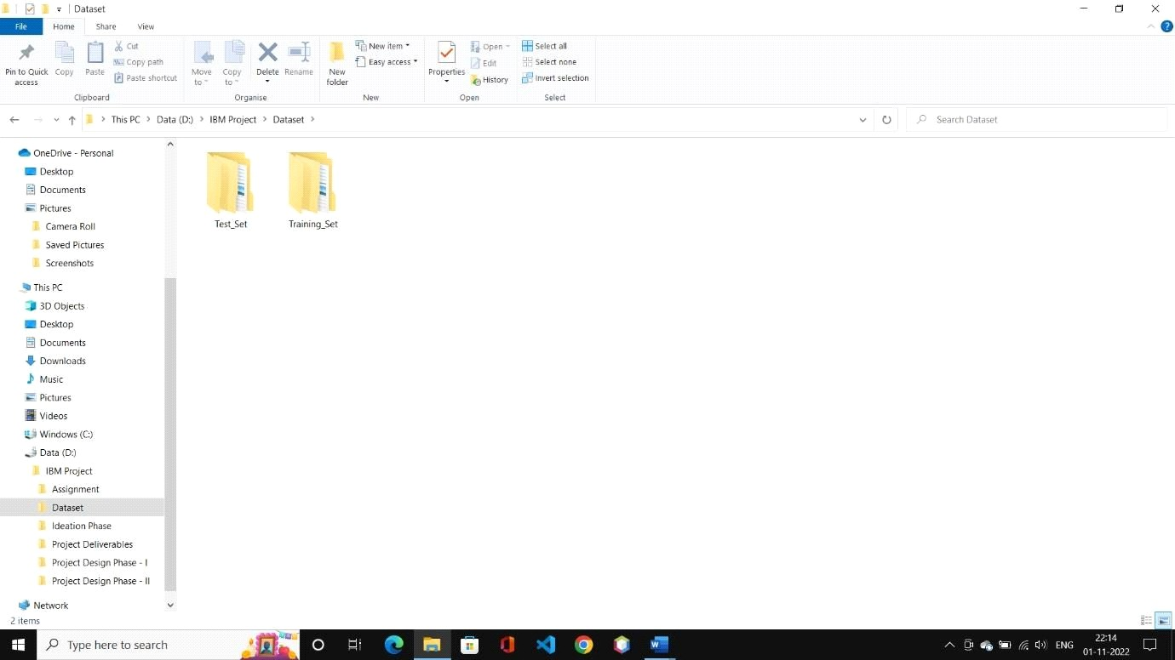

|  |  |
| --- | --- |
| D:\IBM  Project\ | Dataset\Test_Set |
|  | |
|  | |

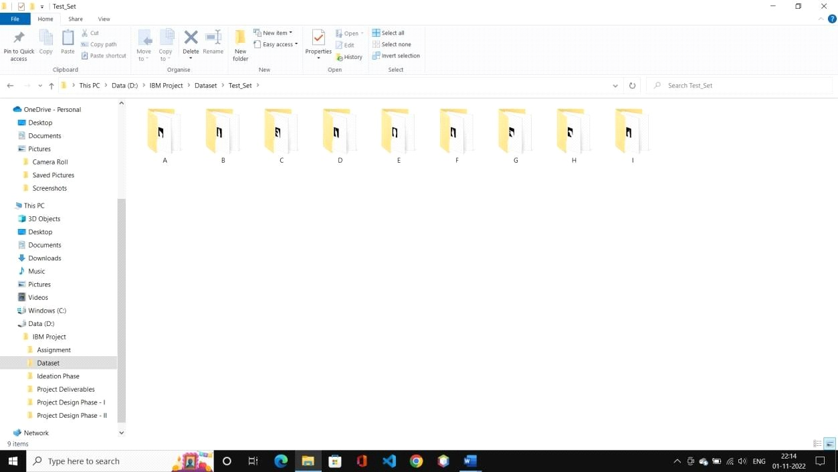

\Dataset\Test_Set\A

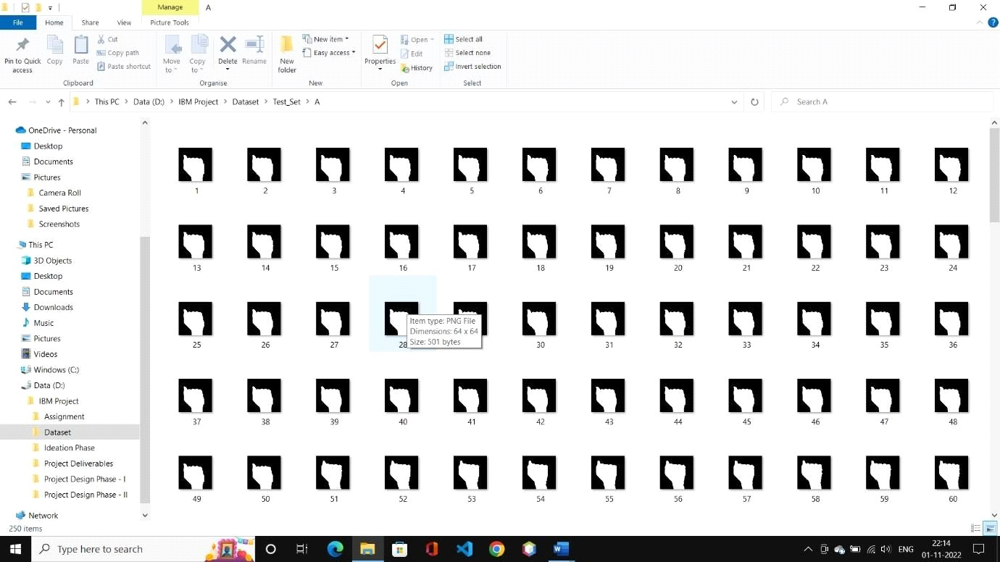

|  |
| --- |
| D:\IBM Project\Dataset\Test_Set\B |
|  |
|  |

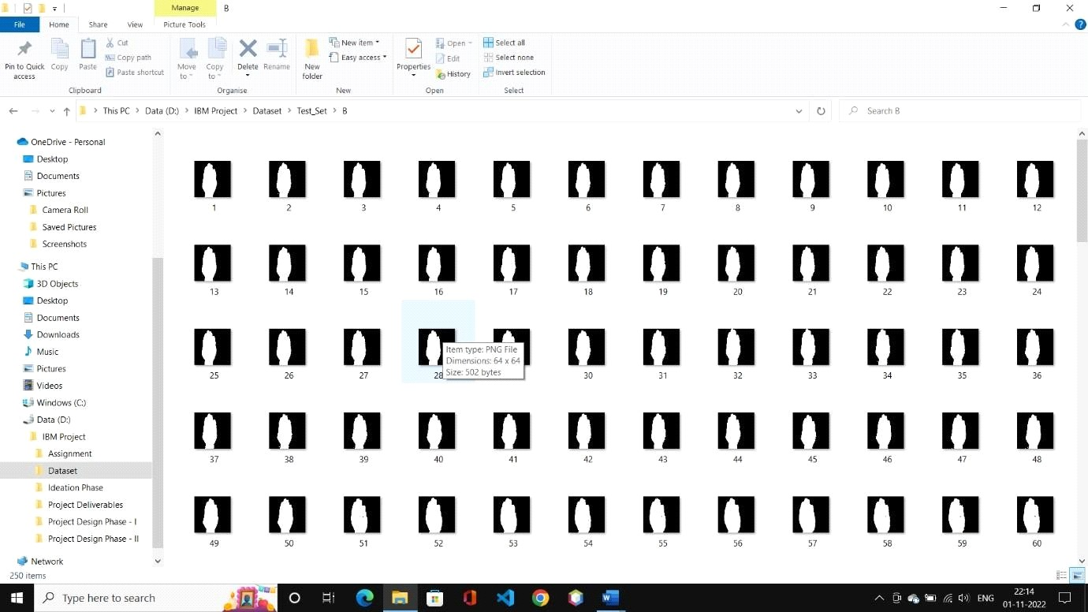

\Dataset\Training_Set

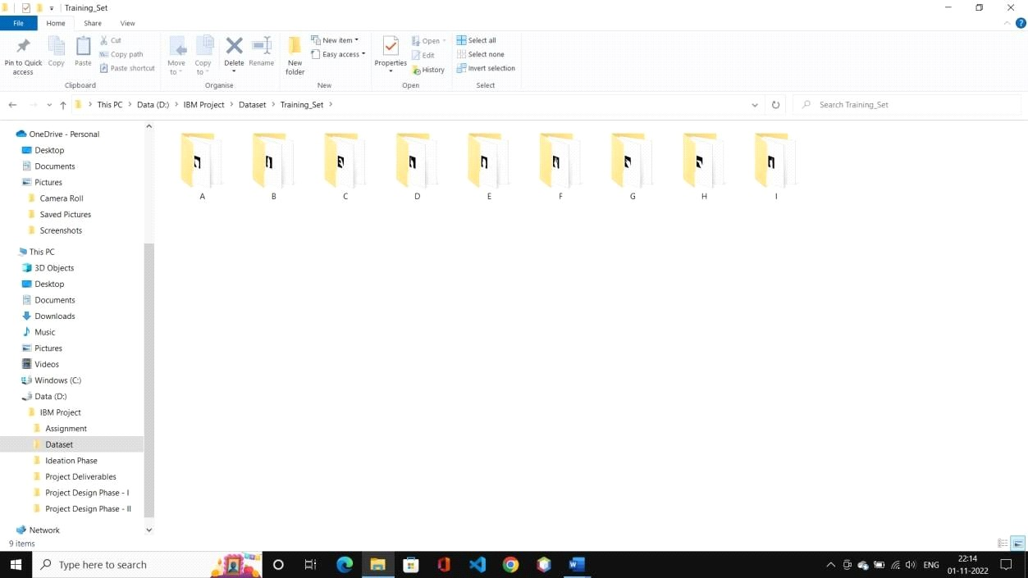

|  |
| --- |
| D:\IBM Project\Dataset\Training_Set\C |
|  |
|  |

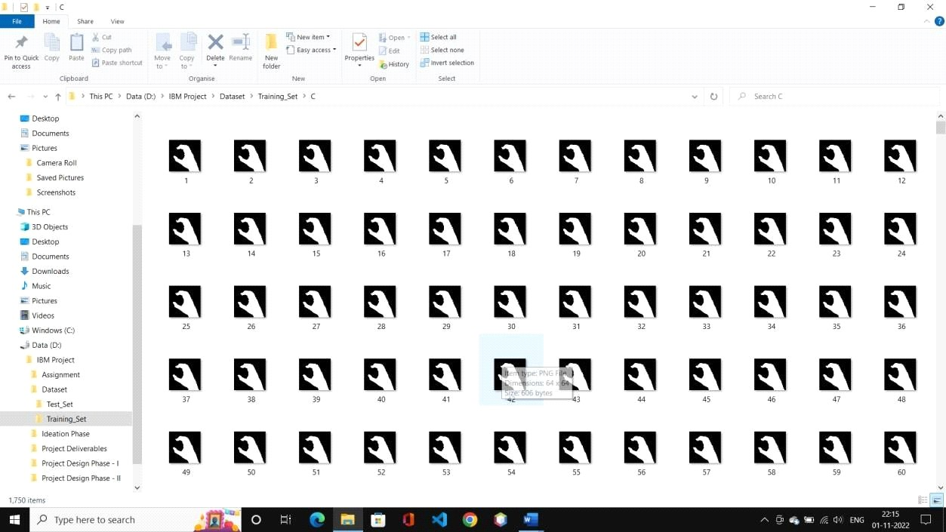

\Dataset\Training_Set\D

